St. Cloud High School

Media Center Collection Development Plan and Action Plan

2024-2025

Written by Tiffany Wright

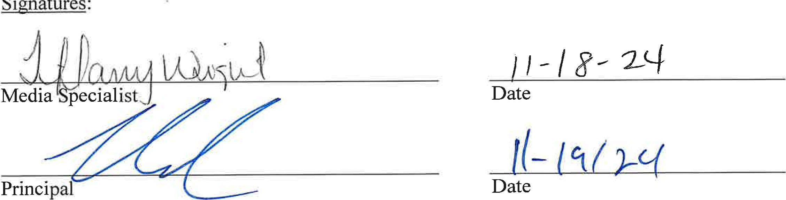

Signatures

:

|  |  |  |  |  |  |
| --- | --- | --- | --- | --- | --- |
| |  |  | | --- | --- | |  | /18/ZD29 | |  |  | |  |

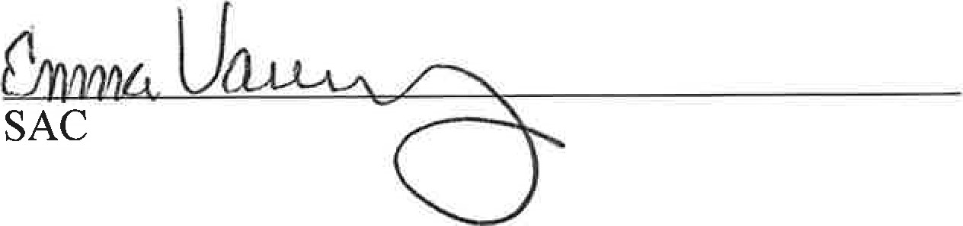 Date

2 1

Purpose Statement:

The purpose of this plan is to serve as a guideline for selecting materials that will serve the needs of both students and classroom while supporting curriculum and igniting a love of reading.

Background Statement:

Vision: Saint Cloud High School will outperform all other schools in the state of Florida.

Mission: St. Cloud High School is a positive, nurturing and safe environment where everyone participates in building pathways to success through rigor, hard work, responsibility and accountability.

Failure is not an option.

For a full breakdown of our population at the time of writing, please see below.

2586 Demographic Data

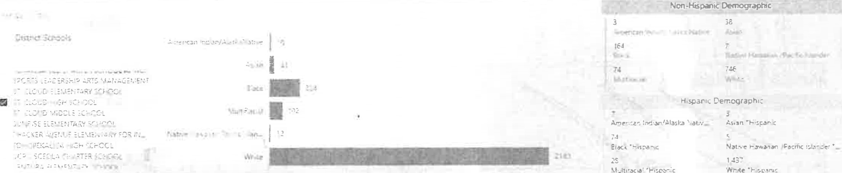

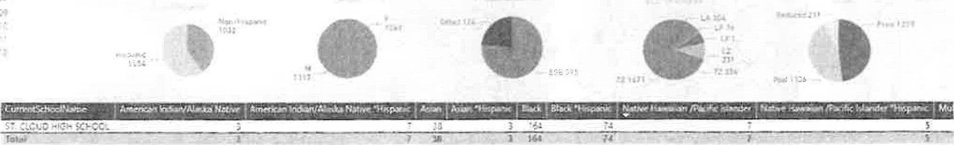

Responsibility for Collection/Development:

The Osceola County School Board holds the final say in media center material acquisition. The certified School Media Specialist will work collaboratively with academic coaches, teachers, and students to identify needs and develop the collection with approval from administration.

Mission, Vision, and Objectives of Selection:

The Osceola Countv School Librarians' Association: "The Osceola County School Librarians' Association supports literacy and curriculum through school media programs by promoting collaboration, emphasizing information literacy, technology skills cultivating the love of reading with students, colleagues and our community."

Mission: Inspiring all learners to reach their highest potential as responsible, productive citizens

Vision: The School District of Osceola County will work in partnership with families and the community to ensure all learners develop the essential knowledge and skills to strengthen our thriving community.

Obiectives of Selection: The Osceola County School Board Rule 4.22 (revised on 8/16/22) addresses the objectives of selection:

The primary objective of the school library/media center is to implement, enrich, and support the educational program of the School District and its schools. The school library/media center shall provide a wide range of materials on all levels of difficulty, with diversity of appeal, and the representation of different points of view. For the purpose of this School Board Rule, "educational media materials" in school libraries/media centers shall be defined to include, but shall not be limited to, the following categories: books, periodicals, and other print materials; films; videos; and/or software, etc.

The School Board asserts that the responsibility of the school library/media center is to provide

1. Instructional and supplemental materials that enrich and support the curriculum, taking into consideration the varied interest, abilities, and maturity levels of the students being served.
2. Materials that stimulate growth in factual knowledge, literary appreciation, aesthetic values, and ethical standards.
3. A background of information enabling students to make intelligent judgments in their daily
4. Materials on opposing sides of controversial issues in order that students may develop, under guidance, the practice of critical analysis of all media.
5. Materials representative of the many religious, ethnic, and cultural groups and their contributions to the heritage and culture of America and the world.
6. A comprehensive collection appropriate for the users of the media center placing principle above personal opinion and reason above prejudice in the selection of materials of the highest quality.

4 1 2

Legal Responsibility for Selection: The School Board is legally responsible for all matters relating to the operation of the School District of Osceola County. The responsibility for the selection of educational media materials, regardless of whether the book is purchased, donated, or otherwise made available to students is delegated to a school district employee who holds a valid educational media specialist certificate. School principals are responsible for overseeing compliance with School District procedures for selecting school library media center materials.

Parental Responsibility: Parents shall have the right to review materials in the media center and to request that it be noted in the student's library record that the student not be allowed to check out certain material.

Criteria for Selection of Educational Media Materials:

1. The standards to determine the propriety of the educational media materials shall be pursuant to Florida Statutes 847.001 and 847.002.
2. Educational media materials shall be evaluated and selected to implement, enrich, and support the educational programs of the School District and its schools. Materials placed in school library/ media center collections shall meet the criteria set forth in the School Board policy.
3. The content of the School District's approved curriculum shall determine the need for the use of educational media materials.
4. First consideration shall be given to the needs of the individual school based upon knowledge of the curriculum, of the existing collection, and of the needs of children and youth. Requests from users of the collection, (i.e., administrators, faculty, parents, and students) shall be given high priority.
5. Materials shall be considered on the basis of accuracy of content, overall purpose, timeliness, importance of the subject matter, quality of the writing/production, readability and popular appeal, authoritativeness, comprehensiveness of material, reputation of the publisher/producer, reputation and significance of the author/artist/composer/producer, format and price.
6. In determining the suitability and value of the material included in the collection, consideration of the following elements must be given:

I . Religion — Material shall be factual, unbiased, and shall represent all major religions.

* 1. Ideologies/Philosophies — Material shall contain factual information on any ideology or philosophy that exerts a strong force in society.
  2. Sex — Pornographic, sensational, or titillating materials shall not be included.
  3. Profanity — The fact that limited profanity appears in material shall not automatically disqualify a selection. However, care shall be taken to exclude materials using profanity in a lewd or detrimental manner and not in context with the material.
  4. Science — Material shall be factual information about medical and scientific knowledge, without any biased selection of facts.

Procedures for Selection of Educational Media Materials: In selecting materials made available to students through the school library/media center, the school media specialist shall:

1. Consult with reputable, unbiased, professionally recognized reviewing periodicals and school community stakeholders (including, instructional media employees, curriculum consultants, faculty, parents, and community members).
2. Require that educational media materials selections meet the criteria set forth in Section 1006.40(3)(d), Florida Statutes.
3. Ensure school library/media center collections shall:

l . Be based on reader interest.

* 1. Support state academic standards and aligned curriculum.
  2. Support the academic needs of students and faculty.

1. Comply with the following procedures when considering materials to be purchased:

I . Purchase materials which are outstanding and frequently used.

* 1. Periodically replace periodically worn or missing basic items.
  2. Withdraw out-of-date or unnecessary items from the collection or items required to be removed pursuant to this policy and applicable state law; and replaced by new and age-appropriate materials.
  3. Purchase materials in many types of formats: digital, e-books, electronically, paperback, or hardcover.
  4. Examine sets of materials and materials acquired by subscription and purchase only materials that fill a definite need.

1. All School District schools must publish on their school website, a list of all materials maintained in the school library/media center or required as a part of a school-level or grade level reading list.

Selection Aides: Selection aids include, but are not limited to the following resources:

1. School Library Journal
2. Booklist
3. Book Links
4. Publisher's Weekly Children's Books Reviews
5. Horn Book
6. ALA awards lists
7. B.E.S.T. Books
8. Kirkus Reviews
9. Jobbers such as Follett reps, Children's Plus, and Mackin
10. School Library Connection

Challenge Process for Educational Media Materials: Educational media materials deemed by some individuals to be objectionable may be considered by others to have sound educational value. Any concerned parent, Osceola County resident, or employee of the School District may request reconsideration of educational media materials in a school library/media center.

The following challenge procedure shall be followed:

1. The school media specialist shall discuss the matter informally with the complainant explaining the selection procedures for school library/media center materials. If the complainant accepts the explanation given by the school media specialist, then the reconsideration process concludes.
2. If the explanation fails to resolve the objection, the school principal shall ask the complainant initiating the challenge to file, within two (2) weeks, a formal written objection by completing a "Request for Reconsideration of Library Media" form which must reflect that the complainant has read the material in full. Failure to do so results in the conclusion of the reconsideration process.
3. Media Center Advisory Committee

I . Upon receipt of the completed form "Request for Reconsideration of Library Media," the school principal shall forward copies of the form to the appropriate employees on the

7 1 P a g e school-level Media Center Advisory Committee (e.g., a committee of teachers, educational media specialists, and parents of the school).

* 1. Pending a final decision, the challenged educational media material:

• shall not be available for student use; but  shall not be removed from the school library/ media center collection.

* 1. The Media Center Advisory Committee shall:
     + review and consider the objections being raised;
     + read and re-evaluate the challenged educational media material; and
     + report its decision within fifteen (15) working days.
  2. The school principal shall inform the complainant in writing concerning the Media Center Advisory Committee's decision.

1. If the complainant disagrees with the decision rendered by the school-level Media Center Advisory Committee, an Appeal may be filed with the School District Educational Media Materials Review Committee.
2. The Superintendent shall appoint a School District Educational Media Materials Review Committee with the following composition:

l . One (1) representative of the Osceola County Public Library Board;

* + 1. One (1) representative of the general public at large;
    2. One (1) representative of a school parent organization;
    3. One (1) principal from the level at which the complaint originated (K-5, 6-8, or 9-12);
    4. Three (3) school-level instructional employees, including the following:
    5. One (1) certified media specialist from the level at which the complaint originated;
    6. One (l) certified media specialist from another level; and
    7. One (1) classroom teacher from the level at which the complaint originated.

6. Two (2) School District-level instructional employees, including the following:

* + 1. One (1) School District-level instructional employee from the level where the material is in question; and
    2. The Director of Media and Instructional Technology or designee.

1. The School District Review Committee, in carrying out its assigned function, shall:

l . Read, view, or listen to the educational media material in its entirety;

* + 1. Check general acceptance of the educational media material by reading reviews and consulting recommended lists;
    2. Determine the extent to which the educational media material supports the curriculum;
    3. Complete the "Checklist for Reconsideration of Library Media," judging the educational media material for its strength and value as a whole and not in part; and
    4. Forward, within fifteen (15) working days, a written recommendation to the

Superintendent.

1. The Superintendent's designee shall inform the complainant and the school media specialist of the School District Review Committee's decision to retain or withdraw the challenged educational media material.
2. Appeal to Superintendent
   * 1. If the complainant or the school's media specialist is dissatisfied with the School District Review Committee's decision, a written appeal may be filed with the Superintendent.
     2. Failure of the complainant to file a written appeal within thirty (30) days of the School District Review Committee's decision shall result in a conclusion of the reconsideration process, and the decision of the School District Review Committee shall be final.
     3. The Superintendent shall, within thirty (30) days of receipt of the appeal, send the complainant and the school media specialist a written decision.
3. Appeal to the School Board

l . If the complainant or the school's media specialist is dissatisfied with the

Superintendent's decision, a written appeal may be filed with the School Board.

* + 1. An appeal to the School Board of the Superintendent's decision must be filed within ten (10) days after the Superintendent's decision.
    2. Failure of the complainant to file a written appeal within ten (10) days after the Superintendent's decision shall result in a conclusion of the reconsideration process, and the decision of the Superintendent shall be final.

1. The School Board shall consider the decision of the School District Review Committee, the decision of the Superintendent, and any other appropriate documentation (e.g., meeting summaries, material reviews, etc.). The decision of the School Board regarding appropriateness of a particular school library/media center material item shall be considered final.
2. School library/ media center materials in question, can only be removed from circulation and/ or used in the School District through the procedures of this policy.

Loan of School District Educational Media Materials: A. Educational media materials owned by the School Board are not normally made available to non-school-related groups.

Under exceptional circumstances, the Superintendent or designee may approve for loan educational media materials and equipment from a school or the Professional Development Center.

No charge is normally made for the occasional use of educational media materials. However, the borrowing group shall be responsible for any damage occurring during the use of the borrowed educational media materials.

Target Audience:

High school teachers, students, and support staff.

Budgeting and Funding:

School's in Osceola County typically receive funding from the district/state at about $4.50 per student each school year. The budget strip is released in July and then again in January (of next year) and must be approved by the district and spent COMPLETELY by the December break.

| p a g

None of this money can be used to purchase technology. It must be used for instructional materials including print books, ebooks, journals, electronic resources and databases. For any concerns or questions about a material, contact Pam Fordham at the district office. All other Library/Media Center funding must be supplemented with a fundraiser.

Collection Analysis:



St Coud High School Library Collection

•.10Sa •.t





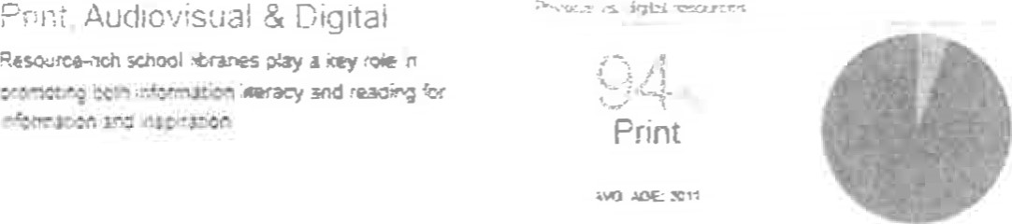 Digital

ect:on Norfictlcn

reg-zes mare han pst kooag meantngs ci —

<.rouieøe s esser.äa!Nonfiction

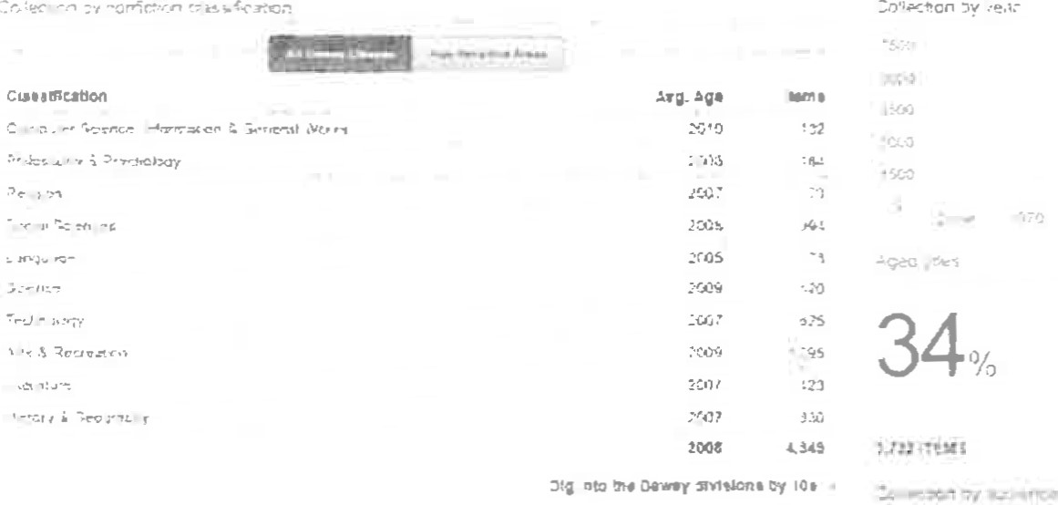

201S 

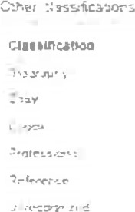 202*

# P a g

• Average age: 2011 or newer (in most areas) Areas in high need:

* Online Fiction
* Graphic Novels

 Spanish Online Fiction Spanish online non-fiction

Spanish Fiction

* Spanish non-fiction
* Lower level books to accommodate ESE, PRE-K and Transition classroom needs  Approved supplemental fiction and non-fiction for library/ classroom support

GOALS:

* Increase circulation in physical and digital books
* Increase class visits and knowledge of offered reading materials
* Weed and update collection as a whole

# | p a



Intellectual Freedom:

We stand with ALA on Intellectual freedom that, "ALA actively advocates in defense of the rights of library users to read, seek information, and speak freely as guaranteed by the First Amendment. A publicly supported library provides free and equal access to information for all people of that community. We enjoy this basic right in our democratic society. It is a core value of the library profession."

Weeding:

It is important to keep a collection fresh and relevant. Having books on the shelf that appear damaged or unsightly is not going to help with circulation. Providing students with books that state Pluto is a plant is also detrimental to knowledge acquisition. The Media Specialist will work with staff, students, and families to understand WHY weeding is necessary. The collection will be evaluated regularly, ergo weeded regularly. The final decision on whether to weed an item or not will rest on the Media Specialist. Additionally, crowded shelves make it harder for students to find materials they want to read.

For when to weed each category refer to the amazingly detailed work of Pamela K. Kramer found here: http://www.islma.org/pdf/weeding.PDF

Replacements:

Items will be replaced as necessary. If an item is lost or damaged beyond acceptable salvation, the patron may be responsible for the original purchase price as indicated in the Destiny Library System.

Special Collections:

Class sets are continuously evaluated for relevancy, date of publishing, frequency of use, and to see if they align with the B.E.S.T standards.

I will work to develop the professional section of the media center to aid teachers in professional development. Material should benefit more than one teacher consider relevancy and publication date. I have been working on and will continue to seek out books in languages that reflect our students first languages. I am passionate about trying to provide books that can be read for fun for all students. Books in their home language can promote reading in a comfortable and less intimidating manner.

Gifts

Gifts of media or books may be accepted at the discretion of the Media Specialist with the understanding that their use or disposition shall be determined, according to the same selection criteria and procedures as purchased material.

Action Plan based on Collection Development Policy:

Objectives:

I . Promote reading of high-interest materials.

1. Research, acquire, and promote high interest materials in electronic forms.
2. Promote innovative inquiry based reading and creating.
3. Strengthen and extend collaboration with classroom teachers.
4. Update the student collection with current and appropriate high quality resources to meet current standards with available funding.

6.Examine circulation and collection statistics to identify needs.

7. Have seating areas, collaborative spaces

Actions:

Generate excitement around reading.

* Engage students and staff in reading events and/or lessons.

Continue to expand both fiction and nonfiction eBook collections as needed.  Aim to have books available in eBook format for those that need and/or desire this format.

* Integrate Makerspace materials into library spaces to support classroom curriculum.
* Use technology to connect students and extend the curriculum.

Promote school and district-wide reading initiatives and events, such as Battle of the Books and Osceola Literacy Events.

Provide PD opportunities to classroom teachers to introduce them to new technology that would benefit their students and could be used for collaborative projects.

Promote reading of high-interest materials through a variety of methods including, but not limited to, book tastings, book talks, and book reviews.

Use reports generated from Destiny and Titlewave to make decisions about need.

